CHWC North West Spain Tour 2025 Report

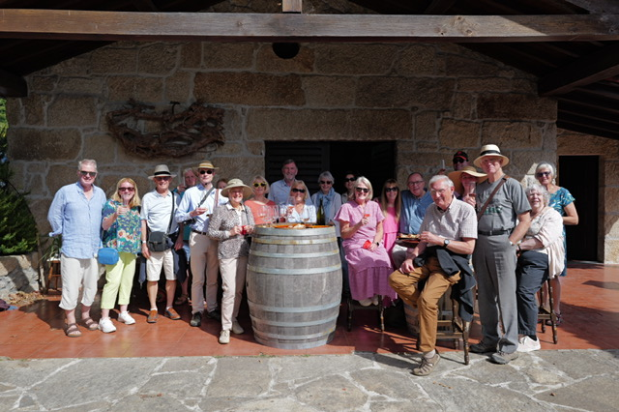

Twenty club members and friends joined our ambitious tour to North West Spain visiting the Ribeira Sacra, Bierzo and Rias Baixas. These regions are all steeped in wine making history but had become largely ignored until the late 1990’s when iconic winemakers like Jose Palacios and Raul Perez began projects in these regions. Big names in Spanish winemaking quickly followed including La Rioja Alta and more recently Vega Sicillia. During this trip we visited some of the most prestigious wineries in each region, the majority are still small, but their knowledge and enthusiasm captivated us all. Experimentation with wine making techniques to develop their own styles is common which allowed us to taste wines of the same grape variety, vineyard and year made differently, for example with or without malolactic fermentation. The tour also included many gastronomic experiences: breads, hams, salamis, cheeses, empanadas, tomatoes of perfect ripeness prepared in different ways, croquetas, seafood of many forms, including fresh clams cooked on an open pine needle fire (see picture) and delicious slow cooked meats.

The geography and scenery are dramatic. On our way to Ponferrada, our first base, we stopped in Ribeira Sacra which has high mountain ranges separated by dramatic river gorges. Our first visit of the trip was to Bodegas Algueira. Their vineyards are on steeply sloped terraces which we were able to experience close up during a river Sil cruise on their boat.
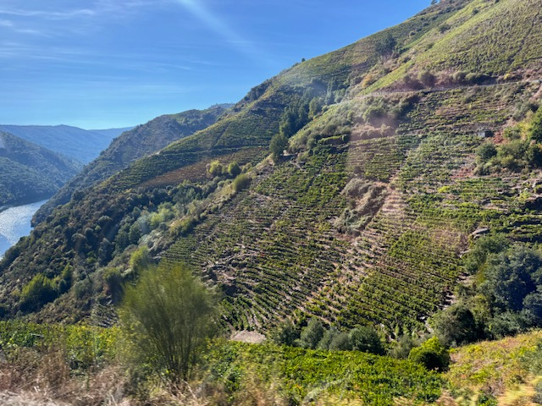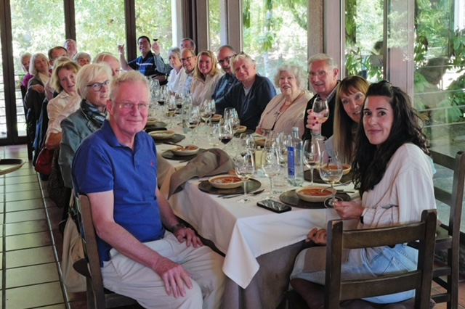

We spent the next day in the very trendy Bierzo region which specialises in fresh red wines, made from the Mencia grape, and delicious Godello white wines. Our two winery visits were contrasting; first Castro Ventosa, the oldest winery in the region, followed by Demencia, a single-handed winery known for its "garage wines" / "garagistes”. So much passion for the land and its restoration based on vineyard regeneration principles.

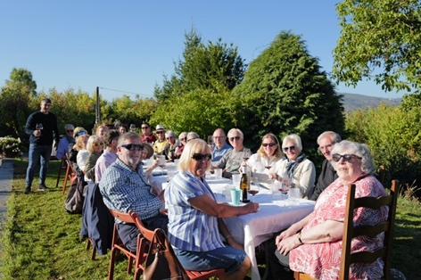

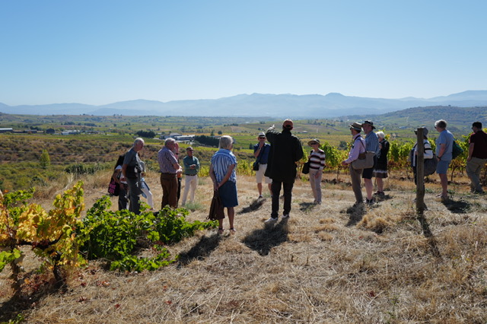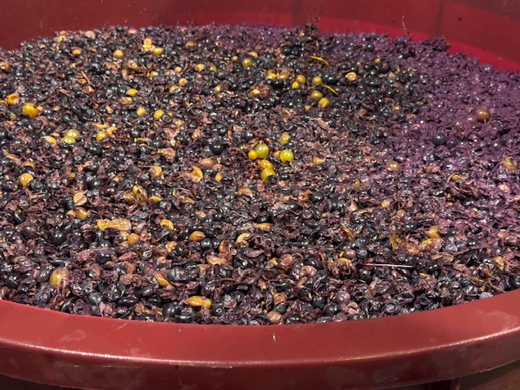

We then headed to Sanxenxo, a coastal resort, which would be our base for the rest of the trip whilst we visited Rias Baixas. On our way we stopped to visit Finca Scintilla, in Ribeira Sacra, close to the Miño river. We tased many wines from the barrel and then the bottle. A private chef prepared a delicious lunch followed by our host presenting an ancient Celtic ritual from Galicia called Queimada Con Su Conxuro.

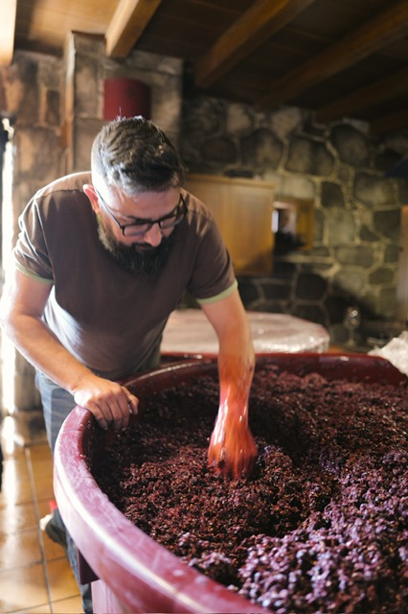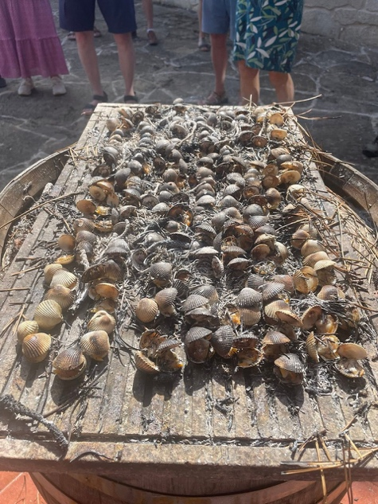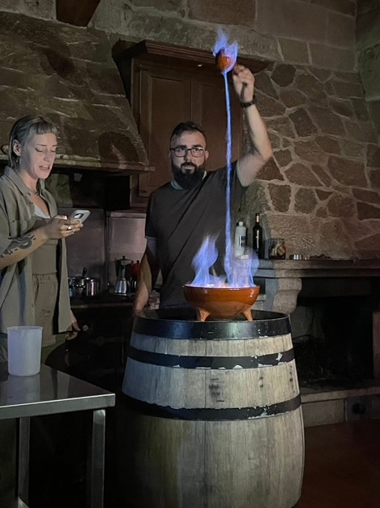

The coastal Rias Baixas region has become famous for white wines made from Albarino grapes. Over two days we visited three wineries. The first two were Forjas de Salines winery and Lagar de Fornelos (owned by la Rioja Alta). Very different but equally compelling styles of making Albarino white wines. So interesting to compare and understand how the region is developing and hearing differing local expert winemakers views on how to get the best expressions of their vineyard plots, often very small, in their wines.

On our last day we visited the renowned Bodegas Alabamar, where we walked in their vineyards under traditional canopy trained vines. We then enjoyed a traditional feast, prepared by the winemaker’s mother, during which we tasted of 11 of the estate’s wines!

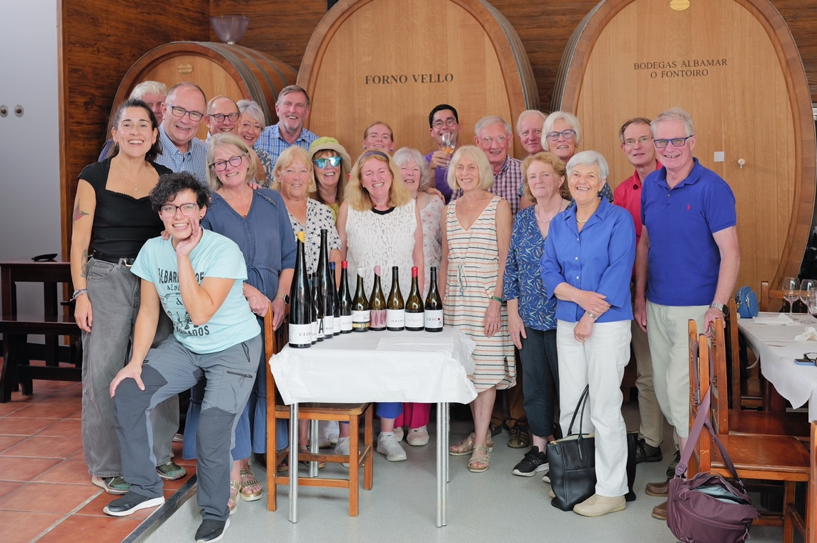

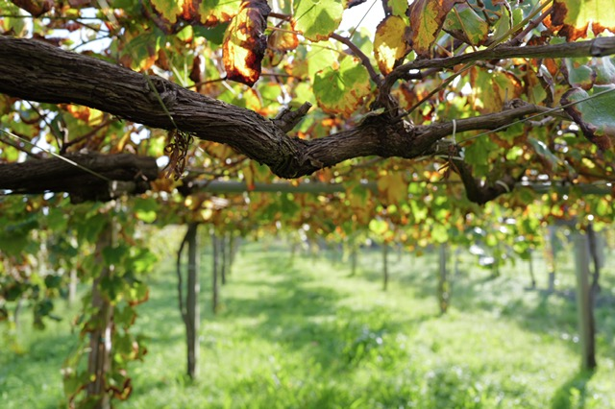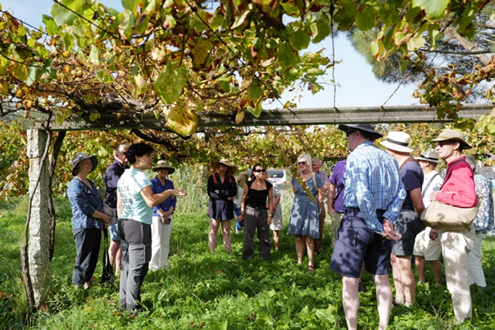

To sum up, a great experience visiting one of the less well known, but up-and-coming, Spanish wine regions. Universally the winemakers showed passion and skill, producing the best expressions of their local grape varieties. Overall, the group preferred the white wines, both still and sparkling. The reds split the crowd as many are light with a bit too much acidity at times, but time will tell how they evolve.

Ian Ellis, October 2025

